16.75: Refer to Equation (16.31) and Figure (16.38). The sound travels a distance 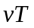 and the plane travels a distance 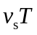 before the boom is found. So, 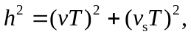 or 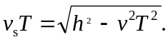 From Equation (16.31), sin 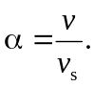 Then, 